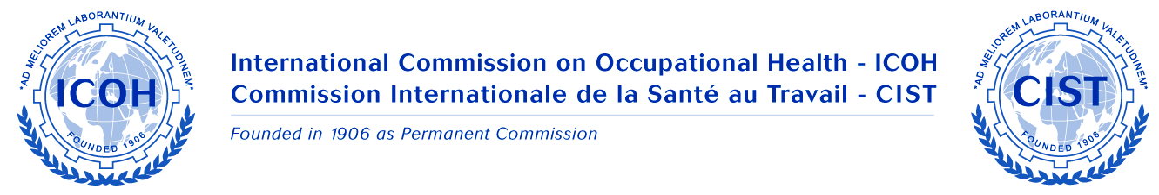

Meeting of ICOH National Secretaries

in connection with an International Symposium 'Towards Better Work and Well-being', organized by the Finnish Institute of Occupational Health

Date 10 February 2010, 12.10–14.00
Venue Hotel Crowne Plaza, Helsinki, Finland

Participants
Ms. Irene Karanja, ICOH National Secretary for Kenya
Dr. Ari Kaukiainen, ICOH National secretary for Finland
Ms. Suvi Lehtinen, ICOH, Vice President
Prof. Jorma Rantanen, ICOH, Past President

Topics discussed

1. Status report from the countries

Ms. Irene Karanja and Dr. Ari Kaukiainen briefly described the activities that they had carried out in connection with the ICOH National Secretary tasks.

The NSs identified as challenges in their tasks the following:
- the e-mail addresses of the members in the country may be outdated, and it may be difficult to trace them
- the bank transfer of the membership payment is still somewhat problematic in developing countries
- the new PayPal system on ICOH website will be checked for its feasibility.

2. Comments to the Draft Work Plan 2009–2012

There were no major comments as to the contents of the Work Plan 2009–2012.

3. Special needs and wishes of the National Secretaries related to ICOH activities

The need for having benefits related to being an ICOH member - described in a clear way - was identified. This kind of material would help the National Secretaries to explain more easily to the potential members why it would be worthwhile to become a member in ICOH.

It was noted that ICOH has made a great deal of various decisions in order to facilitate the joining of young members and members from developing and transitory countries.

Suvi Lehtinen informed that there are several tools available on the ICOH website that can be utilized for membership campaigns at the country level. One of the most obvious places for membership campaigns are symposia and conference organized by ICOH Scientific Committees.

4. ICOH website - National Secretaries' corner

Suvi Lehtinen introduced the ICOH website and the National Secretaries' corner in particular. She encouraged the NSs to utilize the website as every NS can have access to the membership list of his/her own country.

5. ICOH Sustaining and Affiliate Members in the countries

The preliminary idea of ICOH to carry out a survey on the status of OSH in the countries, in collaboration with ICOH National secretaries, was briefly discussed. One of the items in the questionnaire will be to chart the major OSH organizations and professional associations in the countries. This information can later be utilized for raising awareness about ICOH activities.

6. Other issues

Irene Karanja promised to check what the situation of a Pan-African Occupational Health and Safety Conference is. It would provide a good forum for organizing a meeting of ICOH NS in Africa in that connection.

Notes made by SL

